Delhi Public School

Informatics Practices project

Marvel VS DC

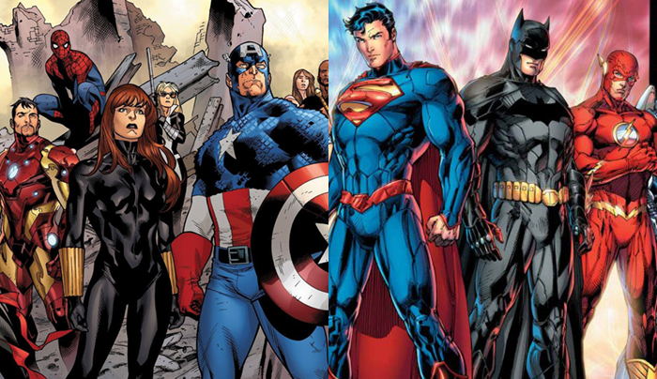

Name: Darsh Gandhi Roll no:

Class: 12th Section: C

ACKNOWLEDGEMENT

I hereby thank the school and the staff of the computer department for all the guidance and support extended to me during the course of this project.

My special thanks are due to the principal for providing us with a right platform and environment to complete the project.

My sincere thanks to Ms. Madhurima Kashyap our Informatics Practices teacher for her able guidance, unflinching support and the affectionate touch without which this project would not have been a success.

Finally, I thank all those who have directly or indirectly contributed to the success of this project.

Name: Antony Francis

Roll No:

Contents

* Hardware and software requirements
* What is NetBeans?
* Introduction to MySQL
* Aims and Objectives of the project
* Advantages of the project
* Table structures
* User interface
* Declaration

Hardware requirement

* Monitor
* Keyboard
* Mouse
* CPU
* CD drive

Software requirement

* Any standard OS(Windows or Mac)
* Java NetBeans IDE
* MySQL

Java Netbeans IDE

NetBeans is a [software development](https://en.wikipedia.org/wiki/Software_development) [platform](https://en.wikipedia.org/wiki/Platform_(computing)) written in [Java](https://en.wikipedia.org/wiki/Java_(programming_language)). The NetBeans Platform allows applications to be developed from a set of modular [software components](https://en.wikipedia.org/wiki/Software_component) called modules. Applications based on the NetBeans Platform, including the NetBeans [integrated development environment](https://en.wikipedia.org/wiki/Integrated_development_environment) (IDE), can be extended by [third party developers](https://en.wikipedia.org/wiki/Third_party_developer).

The NetBeans IDE is primarily intended for development in Java, but also supports other languages, in particular [PHP](https://en.wikipedia.org/wiki/PHP), [C](https://en.wikipedia.org/wiki/C_(programming_language))/[C++](https://en.wikipedia.org/wiki/C%2B%2B) and HTML5



NetBeans is [cross-platform](https://en.wikipedia.org/wiki/Cross-platform) and runs on [Microsoft Windows](https://en.wikipedia.org/wiki/Microsoft_Windows), [Mac OS X](https://en.wikipedia.org/wiki/Mac_OS_X), [Linux](https://en.wikipedia.org/wiki/Linux), [Solaris](https://en.wikipedia.org/wiki/Solaris_(operating_system)) and other platforms supporting a compatible [JVM](https://en.wikipedia.org/wiki/Java_Virtual_Machine).

The editor supports many languages from Java, C/C++, XML and HTML, to PHP, Groovy, Javadoc, JavaScript and JSP. Because the editor is extensible, you can plug in support for many other languages.

The NetBeans Team actively supports the product and seeks feature suggestions from the wider community. Every release is preceded by a time for Community testing and feedback.[[5]](https://en.wikipedia.org/wiki/NetBeans#cite_note-5) Over 18 million downloads of the NetBeans IDE to date, and over 800,000 participating developers, the NetBeans project is thriving and continues to grow.

MYSQL

MySQL  is an [open-source](https://en.wikipedia.org/wiki/Open-source) [relational database management system](https://en.wikipedia.org/wiki/Relational_database_management_system) (RDBMS). Its name is a combination of "My", the name of co-founder [Michael Widenius](https://en.wikipedia.org/wiki/Michael_Widenius)'s daughter, and "[SQL](https://en.wikipedia.org/wiki/SQL)", the abbreviation for [Structured Query Language](https://en.wikipedia.org/wiki/Structured_Query_Language).

The MySQL development project has made its [source code](https://en.wikipedia.org/wiki/Source_code) available under the terms of the [GNU General Public License](https://en.wikipedia.org/wiki/GNU_General_Public_License), as well as under a variety of [proprietary](https://en.wikipedia.org/wiki/Proprietary_software) agreements. MySQL was owned and sponsored by a single [for-profit](https://en.wikipedia.org/wiki/Business) firm, the [Swedish](https://en.wikipedia.org/wiki/Sweden) company [MySQL AB](https://en.wikipedia.org/wiki/MySQL_AB), now owned by [Oracle Corporation](https://en.wikipedia.org/wiki/Oracle_Corporation). For proprietary use, several paid editions are available, and offer additional functionality.



Aims and objectives

The objective of the software project is to develop a computerized system to ease the buying of movies and comics.

The proposed software system is expected to do the following functionality-

* To provide a user friendly, Graphical User Interface (GUI) based integrated and centralized environment.
* The proposed system should enable the user to easily purchase movies and comics from the Marvel and DC universes.
* To provide user-friendly interface to interact with a centralized database based on client-server architecture
* In its current scope, the software enables user to retrieve information from centralized database designed with MySQL.

Advantages of the project

* Restrict unauthorised access of the user information by using a OTP(One Time Password) and CAPTCHA.
* Increase the security and safety of data as every user has its own login area.
* Get validated data on movies and comics through constraints implemented on oracle tables.
* Maintain customer details and order details for movies and comics for different customers.
* Provides a recommended section for users depending on their previous orders.

Table Structure

**Accounts**

create table accounts

(acno int primary key,

fname varchar(30),

lname varchar(30),

email varchar(30),

mobile bigint(30),

dob date,

superhero varchar(30),

address varchar(1000));

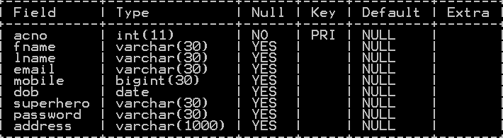

**Data**

create table data

(srno int primary key,

itemno varchar(20),

title varchar(80),

plot varchar(1000),

duration int,

rating double(3,1),

rel varchar(50),

price int);

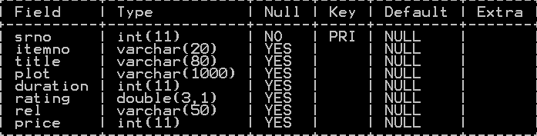

**Inserting Values in table Data-**

insert into data values(1,'batmanc1',"Batman:Rebirth","No one has ever stopped the Caped Crusader. Not The Joker. Not Two-Face. Not even the entire Justice Lea

gue. But how does Batman confront a new hero who wants to save the city from the Dark Knight?",null,9.0,'15 June 2006',3000);

User Interface

**Login Page-**

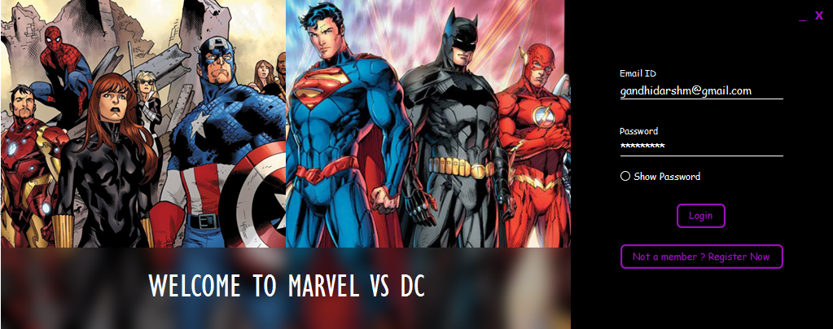

import AppPackage.AnimationClass;

import java.awt.Color;

import java.sql.*;

import javax.swing.ImageIcon;

import javax.swing.JOptionPane;

**Photo Animation-**

public void slideshow()

{

new Thread()

{

int count;

@Override

public void run()

{ImageIcon a = new ImageIcon(getClass().getResource("ani1.png"));

ImageIcon b = new ImageIcon(getClass().getResource("ani2.png"));

ImageIcon c = new ImageIcon(getClass().getResource("ani3.png"));

ImageIcon d = new ImageIcon(getClass().getResource("ani4.png"));

try{

while(true)

{

switch(count)

{

case 0:

al1.setIcon(a);

Thread.sleep(6000);

al2.setIcon(b);

AC.jLabelXLeft(0, -700, 10, 7, al1);

AC.jLabelXLeft(700, 0, 10, 7, al2);

count=1;

break;

case 1:

Thread.sleep(6000);

al1.setIcon(c);

AC.jLabelXRight(-700, 0, 10, 7, al1);

AC.jLabelXRight(0, 700, 10, 7, al2);

count=2;

break;

case 2:

Thread.sleep(6000);

al2.setIcon(d);

AC.jLabelXLeft(0, -700, 10, 7, al1);

AC.jLabelXLeft(700, 0, 10, 7, al2);

count=3;

break;

case 3:

Thread.sleep(6000);

al1.setIcon(a);

AC.jLabelXRight(-700, 0, 10, 7, al1);

AC.jLabelXRight(0, 700, 10, 7, al2);

count=0;

break; }}}

catch(Exception e)

{ JOptionPane.showMessageDialog(null, e.getMessage());}

}

}.start();

}

**Label Animation-**

public void slideshow1()

{

new Thread()

{

int count1;

@Override

public void run()

{

try{

while(true)

{

switch(count1)

{

case 0:

an1.setText("WELCOME TO MARVEL VS DC");

Thread.sleep(6000);

an2.setText("SIGN UP FOR FREE");

AC.jLabelXLeft(0, -700, 10, 7, al1);

AC.jLabelXLeft(700, 0, 10, 7, al2);

count=1;

break;

case 1:

Thread.sleep(6000);

an1.setText("THE COMPLETE DATABASE OF MOVIES AND COMIC

BOOKS”);

AC.jLabelXRight(-700, 0, 10, 7, al1);

AC.jLabelXRight(0, 700, 10, 7, al2);

count=2;

break;

case 2:

Thread.sleep(6000);

an2.setText("AT GREAT DEALS!!!");

AC.jLabelXLeft(0, -700, 10, 7, al1);

AC.jLabelXLeft(700, 0, 10, 7, al2);

count=3;

break;

case 3:

Thread.sleep(6000);

an1.setText("WELCOME TO MARVEL VS DC");

AC.jLabelXRight(-700, 0, 10, 7, al1);

AC.jLabelXRight(0, 700, 10, 7, al2);

count=0;

break; }}}

catch(Exception e)

{ JOptionPane.showMessageDialog(null, e.getMessage());}

}

}.start();

}

public MarvelDC() {

initComponents();

this.setLocationRelativeTo(null);

slideshow1();

slideshow();

al1.requestFocusInWindow();

}

String lemail,lpass,luserpass;//Globally Declared

**Show Password CheckBox-**

private void jCheckBox1ActionPerformed(java.awt.event.ActionEvent evt) {

String a= new String(passlog.getPassword());

if(jCheckBox1.isSelected()==true)

{jCheckBox1.setForeground(new Color(154,15,187));

passlog.setVisible(false);

pshow.setFocusable(true);

pshow.setVisible(true);

pshow.setText(a);}

else

{jCheckBox1.setForeground(new Color(255,255,255));

passlog.setVisible(true);

passlog.setText(pshow.getText());

pshow.setVisible(false);

pshow.setFocusable(false);}

}

**Login Button-**

private void LogButtonMouseClicked(java.awt.event.MouseEvent evt) {

luserpass=new String(passlog.getPassword());

if(jCheckBox1.isSelected()==true)

luserpass=pshow.getText();

lemail=logemail.getText();

Homepage h= new Homepage(lemail);

try

{Class.forName("com.mysql.jdbc.Driver");

Connection conn=DriverManager.getConnection("jdbc:mysql://localhost:3306/ipproject", "root", "");

Statement st=conn.createStatement();

String str1="Select password from accounts where email='"+lemail+"';";

ResultSet rs=st.executeQuery(str1);

if(rs.next())

{lpass=rs.getString("password");

if (lpass.equals(luserpass))

{h.setVisible(true);

this.dispose();}

else

jLabel2.setText("Wrong Email ID or Password");}

}

catch(Exception e)

{JOptionPane.showMessageDialog(null, e.getMessage());}

}

**Navigation to Sign Up Form-**

private void SignformbuttonMouseClicked(java.awt.event.MouseEvent evt) {

SignUp si= new SignUp();

si.setVisible(true);

this.dispose();

}

**Exit Button-**

private void exit1MouseClicked(java.awt.event.MouseEvent evt) {

System.exit(0);

}

private void exit1MouseEntered(java.awt.event.MouseEvent evt) {

exit1.setForeground(new Color(199,2,2));

}

private void exit1MouseExited(java.awt.event.MouseEvent evt) {

exit1.setForeground(new Color(154,15,187));

}

**Minimize Button-**

private void mini1MouseClicked(java.awt.event.MouseEvent evt) {

this.setState(MarvelDC.ICONIFIED);

}

private void mini1MouseEntered(java.awt.event.MouseEvent evt) {

mini1.setForeground(new Color(25,20,209));

}

private void mini1MouseExited(java.awt.event.MouseEvent evt) {

mini1.setForeground(new Color(154,15,187));

}

**Textfield and Label Color Change-**

private void pshowFocusLost(java.awt.event.FocusEvent evt) {

pshow.setForeground(new Color(255,255,255));

l2.setForeground(new Color(255,255,255));

s2.setBackground(new Color(255,255,255));

}

private void pshowFocusGained(java.awt.event.FocusEvent evt) {

pshow.setForeground(new Color(154,15,187));

l2.setForeground(new Color(154,15,187));

s2.setBackground(new Color(154,15,187));

}

private void passlogFocusLost(java.awt.event.FocusEvent evt) {

passlog.setForeground(new Color(255,255,255));

l2.setForeground(new Color(255,255,255));

s2.setBackground(new Color(255,255,255));

}

private void passlogFocusGained(java.awt.event.FocusEvent evt) {

passlog.setForeground(new Color(154,15,187));

l2.setForeground(new Color(154,15,187));

s2.setBackground(new Color(154,15,187));

}

private void LogButtonMouseEntered(java.awt.event.MouseEvent evt) {

ImageIcon i = new ImageIcon(getClass().getResource("login1.png"));

LogButton.setIcon(i);

}

private void LogButtonMouseExited(java.awt.event.MouseEvent evt) {

ImageIcon i = new ImageIcon(getClass().getResource("login.png"));

LogButton.setIcon(i);

}

private void SignformbuttonMouseEntered(java.awt.event.MouseEvent evt) {

ImageIcon i = new ImageIcon(getClass().getResource("Register1.png"));

Signformbutton.setIcon(i);

}

private void SignformbuttonMouseExited(java.awt.event.MouseEvent evt) {

ImageIcon i = new ImageIcon(getClass().getResource("Register.png"));

Signformbutton.setIcon(i);

}

private void logemailFocusGained(java.awt.event.FocusEvent evt) {

logemail.setForeground(new Color(154,15,187));

l1.setForeground(new Color(154,15,187));

s1.setBackground(new Color(154,15,187));

}

private void logemailFocusLost(java.awt.event.FocusEvent evt) {

logemail.setForeground(new Color(255,255,255));

l1.setForeground(new Color(255,255,255));

s1.setBackground(new Color(255,255,255));

}

**Signup Page-** 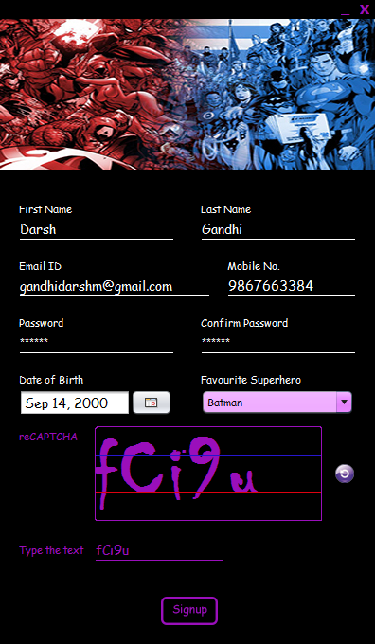

import java.awt.Color;

import java.sql.*;

import java.util.Random;

import javax.swing.JOptionPane;

import javax.swing.DefaultComboBoxModel;

import javax.swing.ImageIcon;

java.util.Date date;

java.sql.Date sqldate ;

public SignUp() {

initComponents();

this.setLocationRelativeTo(null);

jDialog1.setLocationRelativeTo(null);

jLabel4.requestFocusInWindow();

}

String lname,email,pass,conpass,str,str1,captcha,random,userrandom;

public String fname;

int eno,i=0,a=0,b=0;

long mno;

Object hero;//Globally Declared

**Account No-**

try

{Class.forName("com.mysql.jdbc.Driver");

Connection conn=DriverManager.getConnection("jdbc:mysql://localhost:3306/ipproject", "root", "");

Statement st=conn.createStatement();

eno=0;

str="Select max(acno)e from accounts;";

ResultSet rs=st.executeQuery(str);

if(rs.next())

eno=rs.getInt("e")+1;

else

eno=1;

}

catch(Exception e)

{JOptionPane.showMessageDialog(null, e.getMessage());}

**CAPTCHA-**

try

{captcha="qwert1y23456ui7op8a9sdfghjklzxcvbnmQWERTYUIOPASDFGHJKLZXCVBNM";

Random rd=new Random();

StringBuilder sb=new StringBuilder(5);

for(int i=0;i<5;i++)

sb.append(captcha.charAt(rd.nextInt(captcha.length())));

random=sb.toString();

cap.setText(random);}

catch(Exception d)

{JOptionPane.showMessageDialog(null, d.getMessage());}

**Sign Up -**

DefaultComboBoxModel dm=(DefaultComboBoxModel)c1.getModel();

hero=c1.getSelectedItem();

fname=first.getText();

lname=last.getText();

email=emailid.getText();

mno=Long.parseLong(mobile.getText());

pass=new String (pass1.getPassword());

conpass=new String (conpass1.getPassword());

date=birth.getDate();

sqldate=new java.sql.Date(date.getTime());

userrandom=mobile1.getText();

try

{Class.forName("com.mysql.jdbc.Driver");

Connection conn=DriverManager.getConnection("jdbc:mysql://localhost:3306/ipproject", "root", "");

str1="insert into accounts values("+eno+",'"+fname+"','"+lname+"','"+email+"',"+mno+",'"+sqldate+"','"+hero+"','"+pass+"');";

String str="Create table "+eno+fname+" (Srno int,Product varchar(60),Price double(8,2));";

Statement st1=conn.createStatement();

if(pass.equals(conpass))

{if(random.equals(userrandom))

{st1.executeUpdate(str1);

st1.executeUpdate(str);

jDialog1.setVisible(true);

this.dispose();}

else

{jLabel5.setText("Please enter the proper reCAPTCHA text.");

try

{captcha="qwert1y23456ui7op8a9sdfghjklzxcvbnmQWERTYUIOPASDFGHJKLZXCVBNM";

Random rd=new Random();

StringBuilder sb=new StringBuilder(5);

for(int i=0;i<5;i++)

sb.append(captcha.charAt(rd.nextInt(captcha.length())));

random=sb.toString();

cap.setText(random);}

catch(Exception d)

{JOptionPane.showMessageDialog(null, d.getMessage());}}

}

else

jLabel5.setText("You have entered the wrong password.");

}

catch(Exception e)

{JOptionPane.showMessageDialog(null,e.getMessage());}

**Exit Button-**

private void exit1MouseClicked(java.awt.event.MouseEvent evt) {

jDialog1.dispose();

MarvelDC m=new MarvelDC();

m.setVisible(true);

}

private void exit1MouseEntered(java.awt.event.MouseEvent evt) {

exit1.setForeground(new Color(199,2,2));

}

private void exit1MouseExited(java.awt.event.MouseEvent evt) {

exit1.setForeground(new Color(154,15,187));

}

**Textfields and Labels Colour Change-**

private void SignbuttonMouseEntered(java.awt.event.MouseEvent evt) {

ImageIcon i = new ImageIcon(getClass().getResource("signupbut1.png"));

Signbutton.setIcon(i);

}

private void SignbuttonMouseExited(java.awt.event.MouseEvent evt) {

ImageIcon i = new ImageIcon(getClass().getResource("signupbut.png"));

Signbutton.setIcon(i);

}

private void mobile1FocusGained(java.awt.event.FocusEvent evt) {

mobile1.setForeground(new Color(154,15,187));

l10.setForeground(new Color(154,15,187));

s7.setBackground(new Color(154,15,187));

}

private void mobile1FocusLost(java.awt.event.FocusEvent evt) {

mobile1.setForeground(new Color(255,255,255));

l10.setForeground(new Color(255,255,255));

s7.setBackground(new Color(255,255,255));

}

**Homepage-**

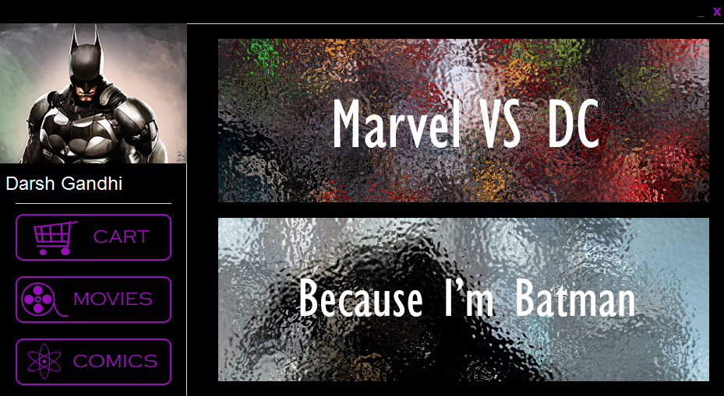

import java.awt.Color;

import java.awt.Dimension;

import java.sql.*;

import javax.swing.ImageIcon;

import javax.swing.JOptionPane;

public String email1,firstid,lastid,hero;

public static String title;//Globally Declared

public Homepage(String email) {

initComponents();

this.setLocationRelativeTo(null);

scrollPane.getVerticalScrollBar().setPreferredSize (new Dimension(0,0));

scrollPane.getHorizontalScrollBar().setPreferredSize (new Dimension(0,0));

scrollPane.getVerticalScrollBar().setMinimumSize(new Dimension(0, 0));

scrollPane.getVerticalScrollBar().setMinimumSize(new Dimension(0, 0));

scrollPane.getVerticalScrollBar().setMaximumSize(new Dimension(0, 0));

scrollPane.getVerticalScrollBar().setMaximumSize(new Dimension(0, 0));

jLabel60.setVisible(false);

jLabel61.setVisible(false);

jLabel62.setVisible(false);

jLabel63.setVisible(false);}

**Display Full Name of the User and Add Superhero Profile Picture-**

try

{Class.forName("com.mysql.jdbc.Driver");

Connection conn=DriverManager.getConnection("jdbc:mysql://localhost:3306/ipproject", "root", "");

Statement st=conn.createStatement();

String str1="Select fname,lname,superhero from accounts where email='"+email1+"';";

ResultSet rs=st.executeQuery(str1);

if(rs.next())

{firstid=rs.getString("fname");

lastid=rs.getString("lname");

hero=rs.getString("superhero");

//System.out.print(hero);

ImageIcon a = new ImageIcon(getClass().getResource("photos/"+hero+"icon.png"));

jLabel55.setIcon(a);

id.setText(" "+firstid+" "+lastid);}

}

catch(Exception e)

{JOptionPane.showMessageDialog(null, e.getMessage());}

**Recommend Movies and Comics according to Superhero-**

public static String recommend(String item)

{try

{Class.forName("com.mysql.jdbc.Driver");

Connection conn=DriverManager.getConnection("jdbc:mysql://localhost:3306/ipproject", "root", "");

Statement st=conn.createStatement();

String str1="Select title from data where itemno='"+item+"';";

ResultSet rs=st.executeQuery(str1);

if(rs.next())

{ title=rs.getString("title");}

}

catch (Exception ex) {

JOptionPane.showMessageDialog(null, ex.getMessage());

}

return title; }

ImageIcon b = new ImageIcon(getClass().getResource("photos/"+hero+".png"));

rec.setIcon(b);

ImageIcon c = new ImageIcon(getClass().getResource("photos/"+hero+"h.png"));

jLabel28.setIcon(c);

ImageIcon d = new ImageIcon(getClass().getResource("photos/"+hero+"c1i.png"));

jLabel45.setIcon(d);

ImageIcon e = new ImageIcon(getClass().getResource("photos/"+hero+"c2i.png"));

jLabel44.setIcon(e);

ImageIcon f = new ImageIcon(getClass().getResource("photos/"+hero+"c3i.png"));

jLabel43.setIcon(f);

ImageIcon g = new ImageIcon(getClass().getResource("photos/"+hero+"c4i.png"));

jLabel36.setIcon(g);

ImageIcon h = new ImageIcon(getClass().getResource("photos/"+hero+"c5i.png"));

jLabel34.setIcon(h);

ImageIcon i = new ImageIcon(getClass().getResource("photos/"+hero+"m1i.png"));

jLabel31.setIcon(i);

if(!hero.equalsIgnoreCase("wonder woman"))

{ImageIcon j = new ImageIcon(getClass().getResource("photos/"+hero+"m2i.png"));

jLabel30.setIcon(j);

if(!hero.equalsIgnoreCase("superman"))

{ImageIcon k = new ImageIcon(getClass().getResource("photos/"+hero+"m3i.png"));

jLabel32.setIcon(k);

if(hero.equalsIgnoreCase("spiderman"))

{ImageIcon l = new ImageIcon(getClass().getResource("photos/"+hero+"m4i.png"));

jLabel40.setIcon(l);

ImageIcon m = new ImageIcon(getClass().getResource("photos/"+hero+"m5i.png"));

jLabel38.setIcon(m);}}}

recommend(hero+"c1");

jLabel50.setText(title);

recommend(hero+"c2");

jLabel51.setText(title);

recommend(hero+"c3");

jLabel52.setText(title);

recommend(hero+"c4");

jLabel37.setText(title);

recommend(hero+"c5");

jLabel35.setText(title);

recommend(hero+"m1");

jLabel47.setText(title);

if(!hero.equalsIgnoreCase("wonder woman"))

{recommend(hero+"m2");

jLabel33.setText(title);

if(!hero.equalsIgnoreCase("superman"))

{recommend(hero+"m3");

jLabel46.setText(title);

if(hero.equalsIgnoreCase("spiderman"))

{recommend(hero+"m4");

jLabel41.setText(title);

recommend(hero+"m5");

jLabel39.setText(title);}}}

**Image Changes on ScrollPanes-**

private void recMouseEntered(java.awt.event.MouseEvent evt) {

rec.setVisible(false);

rec1.setVisible(true); }

private void rec1MouseEntered(java.awt.event.MouseEvent evt) {

rec.setVisible(true);

rec1.setVisible(false);

}

private void jPanel2MouseEntered(java.awt.event.MouseEvent evt) {

ImageIcon j = new ImageIcon(getClass().getResource("com.png"));

jLabel57.setIcon(j);

ImageIcon i = new ImageIcon(getClass().getResource("mov.png"));

jLabel58.setIcon(i);

rec.setVisible(true);

rec1.setVisible(true);

jLabel63.setVisible(false);

jLabel60.setVisible(false);

jLabel61.setVisible(false);

jLabel62.setVisible(false);

}

**Navigation to Open the Page of Selected Product-**

private void jLabel45MouseClicked(java.awt.event.MouseEvent evt) {

Buypage b=new Buypage(hero+"c1",email1);

b.setVisible(true);

}

private void jLabel31MouseClicked(java.awt.event.MouseEvent evt) {

Buypage b=new Buypage(hero+"m1",email1);

b.setVisible(true);

}

private void jLabel17MouseClicked(java.awt.event.MouseEvent evt) {

Buypage b=new Buypage("crossc1",email1);

b.setVisible(true);

}

**Navigation to Different Types of Products and Cart-**

private void jLabel60MouseClicked(java.awt.event.MouseEvent evt) {

MarvelComics m=new MarvelComics(email1);

m.setVisible(true);

this.dispose();

}

private void jLabel61MouseClicked(java.awt.event.MouseEvent evt) {

DCComics m=new DCComics(email1);

m.setVisible(true);

this.dispose();

}

private void jLabel62MouseClicked(java.awt.event.MouseEvent evt) {

MarvelMovies m=new MarvelMovies(email1);

m.setVisible(true);

this.dispose();

}

private void jLabel63MouseClicked(java.awt.event.MouseEvent evt) {

DCMovies m=new DCMovies(email1);

m.setVisible(true);

this.dispose();

}

private void jLabel59MouseClicked(java.awt.event.MouseEvent evt) {

Cart h=new Cart(email1,firstid);

this.dispose();

h.setVisible(true);

}

**Labels Colour and Image Changes-**

private void jLabel58MouseEntered(java.awt.event.MouseEvent evt) {

ImageIcon i = new ImageIcon(getClass().getResource("ho.png"));

jLabel58.setIcon(i);

jLabel63.setVisible(true);

jLabel62.setVisible(true); }

private void jLabel59MouseEntered(java.awt.event.MouseEvent evt) {

ImageIcon i = new ImageIcon(getClass().getResource("Carth1.png"));

jLabel59.setIcon(i);

}

private void jLabel59MouseExited(java.awt.event.MouseEvent evt) {

ImageIcon i = new ImageIcon(getClass().getResource("Carth.png"));

jLabel59.setIcon(i);

}

private void jLabel62MouseEntered(java.awt.event.MouseEvent evt) {

ImageIcon i = new ImageIcon(getClass().getResource("marv1.png"));

jLabel62.setIcon(i);

}

private void jLabel62MouseExited(java.awt.event.MouseEvent evt) {

ImageIcon i = new ImageIcon(getClass().getResource("marv.png"));

jLabel62.setIcon(i);

}

private void jLabel63MouseEntered(java.awt.event.MouseEvent evt) {

ImageIcon i = new ImageIcon(getClass().getResource("dc1.png"));

jLabel63.setIcon(i);

}

private void jLabel63MouseExited(java.awt.event.MouseEvent evt) {

ImageIcon i = new ImageIcon(getClass().getResource("dc.png"));

jLabel63.setIcon(i);

}

**Marvel Movies Page-**

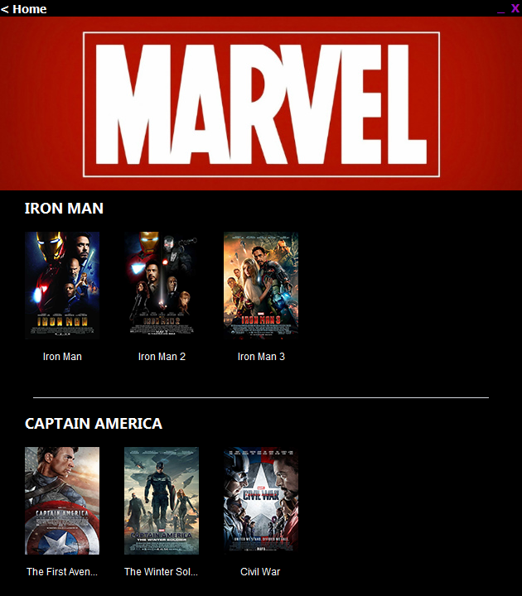

import java.awt.Color;

import java.awt.Dimension;

public MarvelMovies(String email) {

initComponents();

this.setLocationRelativeTo(null);

scrollPane.getVerticalScrollBar().setPreferredSize (new Dimension(0,0));

scrollPane.getHorizontalScrollBar().setPreferredSize (new Dimension(0,0));

scrollPane.getVerticalScrollBar().setMinimumSize(new Dimension(0, 0));

scrollPane.getVerticalScrollBar().setMinimumSize(new Dimension(0, 0));

scrollPane.getVerticalScrollBar().setMaximumSize(new Dimension(0, 0));

scrollPane.getVerticalScrollBar().setMaximumSize(new Dimension(0, 0));

email1=email;

}

**Navigate to Homepage-**

private void home1MouseClicked(java.awt.event.MouseEvent evt) {

Homepage h=new Homepage(email1);

this.dispose();

h.setVisible(true);

}

**Navigation to Open the Page of Selected Product-**

private void jLabel4MouseClicked(java.awt.event.MouseEvent evt) {

Buypage b=new Buypage("iron manm1",email1);

b.setVisible(true);

}

private void jLabel14MouseClicked(java.awt.event.MouseEvent evt) {

Buypage b=new Buypage("captain americam1",email1);

b.setVisible(true);

}

private void jLabel29MouseClicked(java.awt.event.MouseEvent evt) {

Buypage b=new Buypage("spidermanm1",email1);

b.setVisible(true);

}

private void jLabel40MouseClicked(java.awt.event.MouseEvent evt) {

Buypage b=new Buypage("avengersm1",email1);

b.setVisible(true);

}

**DC Movies Page-**

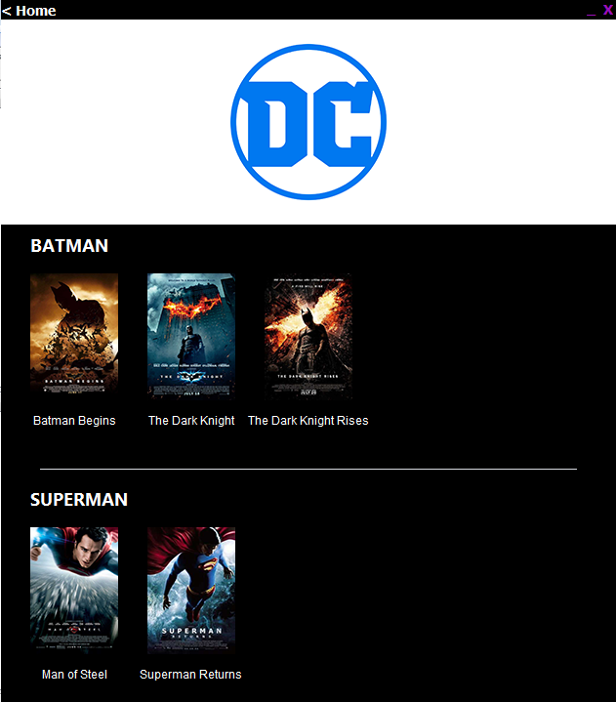

import java.awt.Color;

import java.awt.Dimension;

public MarvelMovies(String email) {

initComponents();

this.setLocationRelativeTo(null);

scrollPane.getVerticalScrollBar().setPreferredSize (new Dimension(0,0));

scrollPane.getHorizontalScrollBar().setPreferredSize (new Dimension(0,0));

scrollPane.getVerticalScrollBar().setMinimumSize(new Dimension(0, 0));

scrollPane.getVerticalScrollBar().setMinimumSize(new Dimension(0, 0));

scrollPane.getVerticalScrollBar().setMaximumSize(new Dimension(0, 0));

scrollPane.getVerticalScrollBar().setMaximumSize(new Dimension(0, 0));

email1=email;

}

**Navigate to Homepage-**

private void home1MouseClicked(java.awt.event.MouseEvent evt) {

Homepage h=new Homepage(email1);

this.dispose();

h.setVisible(true);

}

**Navigation to Open the Page of Selected Product-**

private void jLabel4MouseClicked(java.awt.event.MouseEvent evt) {

Buypage b=new Buypage("batmanm1",email1);

b.setVisible(true);

}

private void jLabel14MouseClicked(java.awt.event.MouseEvent evt) {

Buypage b=new Buypage("supermanm1",email1);

b.setVisible(true);

}

private void jLabel29MouseClicked(java.awt.event.MouseEvent evt) {

Buypage b=new Buypage("wonder womanm1",email1);

b.setVisible(true);

}

private void jLabel41MouseClicked(java.awt.event.MouseEvent evt) {

Buypage b=new Buypage("justicem1",email1);

b.setVisible(true);

}

**Marvel Comics Page-**

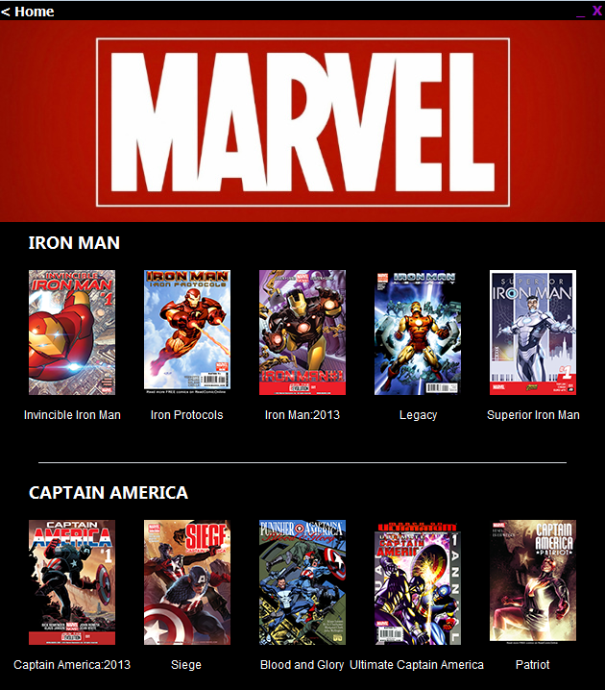

import java.awt.Color;

import java.awt.Dimension;

public MarvelMovies(String email) {

initComponents();

this.setLocationRelativeTo(null);

scrollPane.getVerticalScrollBar().setPreferredSize (new Dimension(0,0));

scrollPane.getHorizontalScrollBar().setPreferredSize (new Dimension(0,0));

scrollPane.getVerticalScrollBar().setMinimumSize(new Dimension(0, 0));

scrollPane.getVerticalScrollBar().setMinimumSize(new Dimension(0, 0));

scrollPane.getVerticalScrollBar().setMaximumSize(new Dimension(0, 0));

scrollPane.getVerticalScrollBar().setMaximumSize(new Dimension(0, 0));

email1=email;

}

**Navigate to Homepage-**

private void home1MouseClicked(java.awt.event.MouseEvent evt) {

Homepage h=new Homepage(email1);

this.dispose();

h.setVisible(true);

}

**Navigation to Open the Page of Selected Product-**

private void jLabel4MouseClicked(java.awt.event.MouseEvent evt) {

Buypage b=new Buypage("iron manc1",email1);

b.setVisible(true);

}

private void jLabel14MouseClicked(java.awt.event.MouseEvent evt) {

Buypage b=new Buypage("captain americac1",email1);

b.setVisible(true);

}

private void jLabel29MouseClicked(java.awt.event.MouseEvent evt) {

Buypage b=new Buypage("spidermanc1",email1);

b.setVisible(true);

}

private void jLabel40MouseClicked(java.awt.event.MouseEvent evt) {

Buypage b=new Buypage("avengersc1",email1);

b.setVisible(true);

}

**DC Comics Page-**

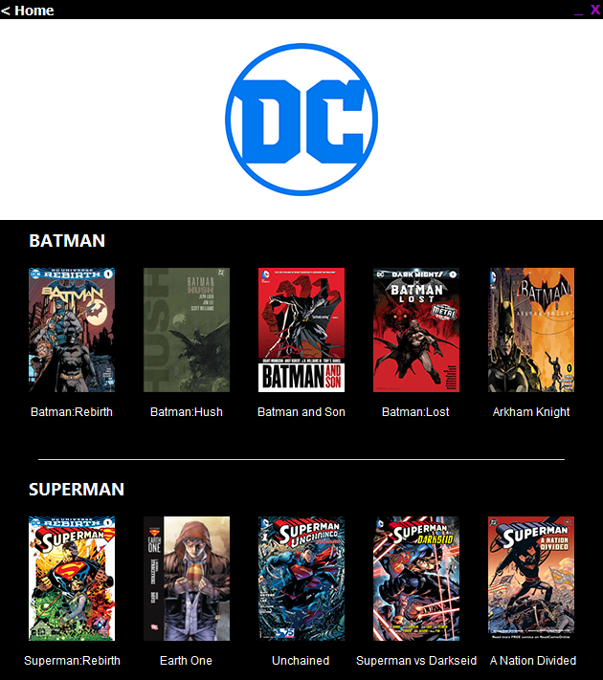

import java.awt.Color;

import java.awt.Dimension;

public MarvelMovies(String email) {

initComponents();

this.setLocationRelativeTo(null);

scrollPane.getVerticalScrollBar().setPreferredSize (new Dimension(0,0));

scrollPane.getHorizontalScrollBar().setPreferredSize (new Dimension(0,0));

scrollPane.getVerticalScrollBar().setMinimumSize(new Dimension(0, 0));

scrollPane.getVerticalScrollBar().setMinimumSize(new Dimension(0, 0));

scrollPane.getVerticalScrollBar().setMaximumSize(new Dimension(0, 0));

scrollPane.getVerticalScrollBar().setMaximumSize(new Dimension(0, 0));

email1=email;

}

**Navigate to Homepage-**

private void home1MouseClicked(java.awt.event.MouseEvent evt) {

Homepage h=new Homepage(email1);

this.dispose();

h.setVisible(true);

}

**Navigation to Open the Page of Selected Product-**

private void jLabel4MouseClicked(java.awt.event.MouseEvent evt) {

Buypage b=new Buypage("batmanm1",email1);

b.setVisible(true);

}

private void jLabel14MouseClicked(java.awt.event.MouseEvent evt) {

Buypage b=new Buypage("supermanm1",email1);

b.setVisible(true);

}

private void jLabel29MouseClicked(java.awt.event.MouseEvent evt) {

Buypage b=new Buypage("wonder womanm1",email1);

b.setVisible(true);

}

private void jLabel41MouseClicked(java.awt.event.MouseEvent evt) {

Buypage b=new Buypage("justicem1",email1);

b.setVisible(true);

}

**Product BuyPage-**

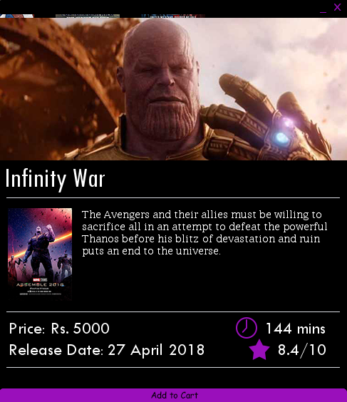

import AppPackage.AnimationClass;

import java.awt.Color;

import java.sql.*;

import javax.swing.ImageIcon;

import javax.swing.JOptionPane;

String title,plot,release,cartname;

int dur,price,cartno,srno;

double rate;//Globally Declared

public Buypage(String item,String email) {

initComponents();

this.setLocationRelativeTo(null);

this.setBackground(new Color(0,0,0,0));}

**Product Information-**

try

{Class.forName("com.mysql.jdbc.Driver");

Connection conn=DriverManager.getConnection("jdbc:mysql://localhost:3306/ipproject", "root","");

Statement st=conn.createStatement();

String str1="Select * from data where itemno='"+item+"';";

ResultSet rs=st.executeQuery(str1);

if(rs.next())

{srno=rs.getInt("srno");

title=rs.getString("title");

plot=rs.getString("plot");

release=rs.getString("rel");

price=rs.getInt("price");

rate=rs.getDouble("rating");

dur=rs.getInt("duration");

}

ImageIcon a = new ImageIcon(getClass().getResource("photos/"+item+"i.png"));

ImageIcon b = new ImageIcon(getClass().getResource("photos/"+item+"p.png"));

if(srno<45)

{

du.setVisible(false);

jLabel11.setVisible(false);}

ti.setText(" "+title);

pl.setText(plot);

pr.setText(price+"");

du.setText(dur+" mins");

ra.setText(rate+"/10");

re.setText(release);

ico.setIcon(a);

pre.setIcon(b);

jLabel14.setText(title);

jLabel12.setText(price+"");

}

catch(Exception e)

{JOptionPane.showMessageDialog(null, e.getMessage());}

**Label Animation-**

private void jLabel16MouseEntered(java.awt.event.MouseEvent evt) {

AC.jLabelYUp(520, 410, 10, 10, jLabel16);

AC.jLabelYUp(580, 470, 10, 10, jLabel12);

AC.jLabelYUp(580, 470, 10, 10, jLabel14);

AC.jLabelYUp(580, 470, 10, 10, jLabel15);

AC.jLabelYUp(575, 465, 10, 10, cartadd);

}

private void jPanel2MouseEntered(java.awt.event.MouseEvent evt) {

AC.jLabelYDown(410, 520, 10, 10, jLabel16);

AC.jLabelYDown(470, 580, 10, 10, jLabel12);

AC.jLabelYDown(470, 580, 10, 10, jLabel14);

AC.jLabelYDown(470, 580, 10, 10, jLabel15);

AC.jLabelYDown(465, 575, 10, 10, cartadd);

}

private void cartaddMouseEntered(java.awt.event.MouseEvent evt) {

ImageIcon i = new ImageIcon(getClass().getResource("cart1.png"));

cartadd.setIcon(i);

}

private void cartaddMouseExited(java.awt.event.MouseEvent evt) {

ImageIcon i = new ImageIcon(getClass().getResource("cart.png"));

cartadd.setIcon(i);

}

**Adding Product to Cart-**

try

{Class.forName("com.mysql.jdbc.Driver");

Connection conn=DriverManager.getConnection("jdbc:mysql://localhost:3306/ipproject", "root", "");

Statement st=conn.createStatement();

String str2="select acno,fname from accounts where email=\""+email+"\"";

ResultSet rs=st.executeQuery(str2);

if(rs.next())

{cartno=rs.getInt("acno");

cartname=rs.getString("fname");}}

catch(Exception e)

{JOptionPane.showMessageDialog(null, e.getMessage());}

}

public void added()

{

new Thread()

{

@Override

public void run()

{

try{

jLabel1.setText("Added item to cart");

Thread.sleep(400);

jLabel1.setText(""); }

catch(Exception e)

{ JOptionPane.showMessageDialog(null, e.getMessage());}

}

}.start();

}

try

{Class.forName("com.mysql.jdbc.Driver");

Connection conn=DriverManager.getConnection("jdbc:mysql://localhost:3306/ipproject", "root", "");

Statement st=conn.createStatement();

srno=0;

String str="Select max(srno)s from "+cartno+cartname+";";

ResultSet rs=st.executeQuery(str);

if(rs.next())

srno=rs.getInt("s")+1;

else

srno=1;}

catch(Exception e)

{JOptionPane.showMessageDialog(null, e.getMessage());}

try

{Class.forName("com.mysql.jdbc.Driver");

Connection conn=DriverManager.getConnection("jdbc:mysql://localhost:3306/ipproject", "root", "");

Statement st=conn.createStatement();

String str3="insert into "+cartno+cartname+" values("+srno+",\""+ti.getText()+"\","+Integer.parseInt(pr.getText())+")";

st.executeUpdate(str3);

added();}

catch(Exception e)

{JOptionPane.showMessageDialog(null, e.getMessage());}

}

**Cart Page-**

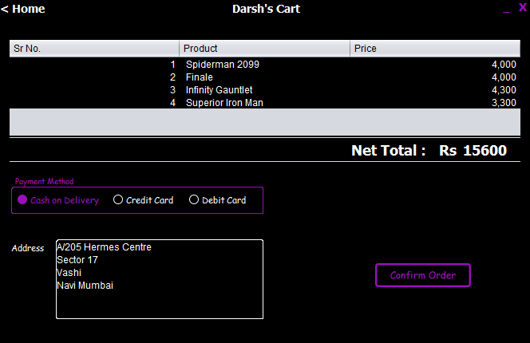

import java.awt.Color;

import java.sql.*;

import java.util.Random;

import javax.swing.ImageIcon;

import javax.swing.JOptionPane;

import javax.swing.table.DefaultTableModel;

String firstname,mail,address,otp,random;

int cartno,sum;

long phoneno;//Globally Declared

public Cart(String email,String firstc) {

initComponents();

this.setLocationRelativeTo(null);

jDialog1.setLocationRelativeTo(null);

jDialog1.setBackground(new Color(0,0,0,0));

Empty.setVisible(false);

l2.setVisible(false);

s2.setVisible(false);

Card.setVisible(false);

Wrong.setVisible(false);

exit1.setVisible(false);

Wrong1.setVisible(false);

jLabel11.setVisible(false);

firstname=firstc;

mail=email;

Conf.setEnabled(false);

try

{Class.forName("com.mysql.jdbc.Driver");

Connection conn=DriverManager.getConnection("jdbc:mysql://localhost:3306/ipproject", "root", "");

Statement st=conn.createStatement();

String str2="select acno,address,mobile from accounts where email=\""+email+"\"";

ResultSet rs=st.executeQuery(str2);

if(rs.next())

{cartno=rs.getInt("acno");

address=rs.getString("address");

adr.setText(address);

phoneno=rs.getLong("mobile");}}

catch(Exception e)

{JOptionPane.showMessageDialog(null, e.getMessage());}}

private void formWindowOpened(java.awt.event.WindowEvent evt) {

home2.setText(firstname+"'s Cart");

}

**Display All Products in Cart and Total Amount-**

DefaultTableModel nr=(DefaultTableModel)ta1.getModel();

nr.setRowCount(0);

try

{Class.forName("com.mysql.jdbc.Driver");

Connection conn=DriverManager.getConnection("jdbc:mysql://localhost:3306/ipproject", "root", "");

Statement st=conn.createStatement();

String str="Select * from "+cartno+firstc+";";

ResultSet rs=st.executeQuery(str);

while(rs.next())

{int srno=rs.getInt("srno");

String prod=rs.getString("product");

int price=rs.getInt("price");

nr.addRow(new Object[]{srno,prod,price});}

if(ta1.getRowCount()==0)

Empty.setVisible(true);

rs.close();

st.close();

conn.close();}

catch(Exception e)

{JOptionPane.showMessageDialog(null, e.getMessage());}

try

{Class.forName("com.mysql.jdbc.Driver");

Connection conn=DriverManager.getConnection("jdbc:mysql://localhost:3306/ipproject", "root", "");

Statement st=conn.createStatement();

String str="Select sum(price)p from "+cartno+firstc+";";

ResultSet rs=st.executeQuery(str);

if(rs.next())

{ sum=rs.getInt("p");

total.setText(sum+"");}

rs.close();

st.close();

conn.close();}

catch(Exception e)

{JOptionPane.showMessageDialog(null, e.getMessage());}

**Choose Mode of Payment-**

private void r3ActionPerformed(java.awt.event.ActionEvent evt) {

DefaultTableModel nr=(DefaultTableModel)ta1.getModel();

if(r3.isSelected()==true)

{r3.setForeground(new Color(154,15,187));

r1.setForeground(new Color(255,255,255));

r2.setForeground(new Color(255,255,255));

l2.setText("Debit Card Number");

l2.setVisible(true);

s2.setVisible(true);

Card.setVisible(true);

if(ta1.getRowCount()!=0)

Conf.setEnabled(true);}

else

{r3.setForeground(new Color(255,255,255));}

}

private void r1ActionPerformed(java.awt.event.ActionEvent evt) {

DefaultTableModel nr=(DefaultTableModel)ta1.getModel();

if(r1.isSelected()==true)

{r1.setForeground(new Color(154,15,187));

r2.setForeground(new Color(255,255,255));

r3.setForeground(new Color(255,255,255));

l2.setVisible(false);

s2.setVisible(false);

Card.setVisible(false);

if(ta1.getRowCount()!=0)

Conf.setEnabled(true);}

else

{r1.setForeground(new Color(255,255,255));}

}

private void r2ActionPerformed(java.awt.event.ActionEvent evt) {

DefaultTableModel nr=(DefaultTableModel)ta1.getModel();

if(r2.isSelected()==true)

{r2.setForeground(new Color(154,15,187));

r1.setForeground(new Color(255,255,255));

r3.setForeground(new Color(255,255,255));

l2.setText("Credit Card Number");

l2.setVisible(true);

s2.setVisible(true);

Card.setVisible(true);

if(ta1.getRowCount()!=0)

Conf.setEnabled(true);}

else

{r2.setForeground(new Color(255,255,255));}

}

**Order Confirmed-**

private void ConfMouseClicked(java.awt.event.MouseEvent evt) {

jDialog1.setVisible(true);

this.setVisible(false);

try

{Class.forName("com.mysql.jdbc.Driver");

Connection conn=DriverManager.getConnection("jdbc:mysql://localhost:3306/ipproject", "root", "");

Statement st=conn.createStatement();

String str="Update accounts set address=\""+adr.getText()+"\" where acno="+cartno+";";

st.executeUpdate(str);

}

catch(Exception e)

{JOptionPane.showMessageDialog(null, e.getMessage());}

smsotp o=new smsotp();

o.sendSms(phoneno,random,firstname,sum);

}

**OTP Dialog Box-**

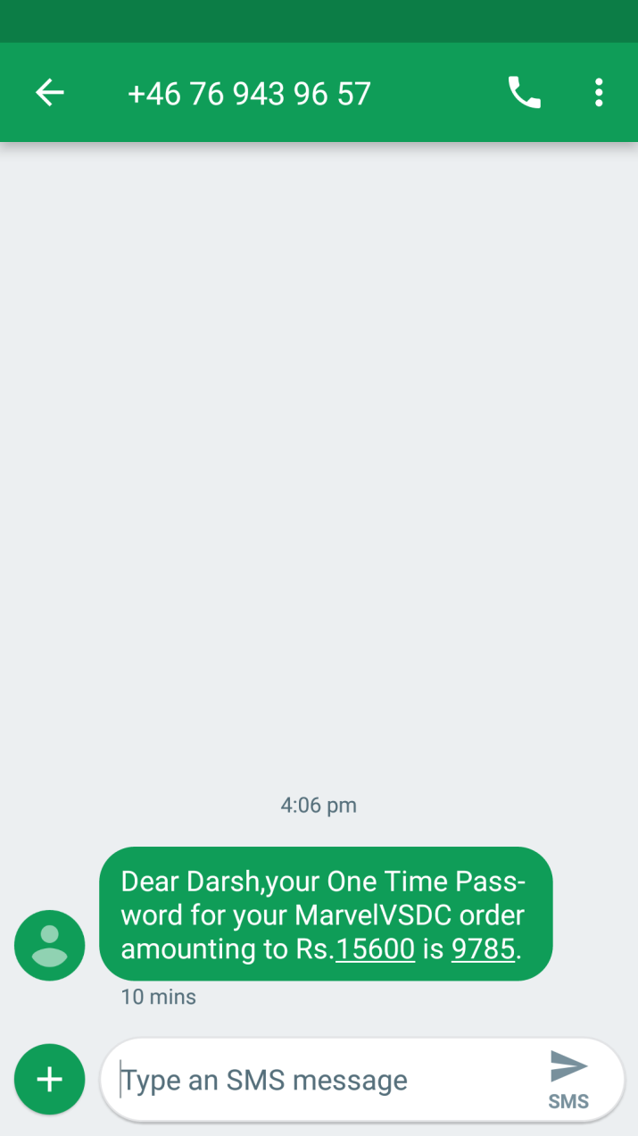

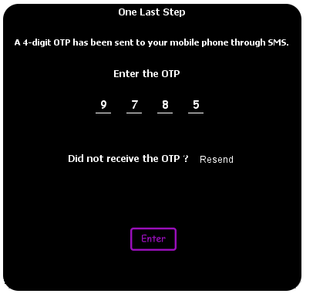

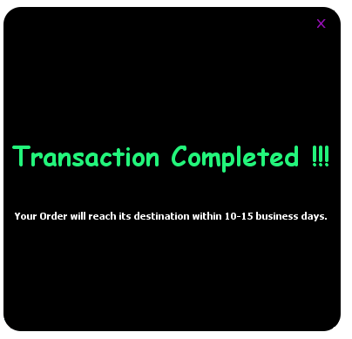

private void o1KeyTyped(java.awt.event.KeyEvent evt) {

o2.requestFocus();

}

private void o2KeyTyped(java.awt.event.KeyEvent evt) {

o3.requestFocus();

}

private void o3KeyTyped(java.awt.event.KeyEvent evt) {

o4.requestFocus();

}

private void o4KeyTyped(java.awt.event.KeyEvent evt) {

Enter.requestFocus();

}

private void EnterMouseClicked(java.awt.event.MouseEvent evt) {

String a=o1.getText().trim()+o2.getText().trim()+o3.getText().trim()+o4.getText().trim();

if(random.equals(a))

{ try

{Class.forName("com.mysql.jdbc.Driver");

Connection conn=DriverManager.getConnection("jdbc:mysql://localhost:3306/ipproject", "root", "");

Statement st=conn.createStatement();

String str="Delete from "+cartno+firstname+";";

st.executeUpdate(str);

}

catch(Exception e)

{JOptionPane.showMessageDialog(null, e.getMessage());}

exit1.setVisible(true);

jLabel11.setVisible(true);

Wrong1.setVisible(true);}

else

Wrong.setVisible(true);

}

private void jLabel8MouseClicked(java.awt.event.MouseEvent evt) {

smsotp o=new smsotp();

o.sendSms(phoneno,random,firstname,sum);

}

**Label Changes-**

private void ConfMouseEntered(java.awt.event.MouseEvent evt) {

ImageIcon i = new ImageIcon(getClass().getResource("Confirm1.png"));

Conf.setIcon(i);

}

private void ConfMouseExited(java.awt.event.MouseEvent evt) {

ImageIcon i = new ImageIcon(getClass().getResource("Confirm.png"));

Conf.setIcon(i);

}

private void EnterMouseEntered(java.awt.event.MouseEvent evt) {

ImageIcon i = new ImageIcon(getClass().getResource("enter1.png"));

Enter.setIcon(i);

}

private void EnterMouseExited(java.awt.event.MouseEvent evt) {

ImageIcon i = new ImageIcon(getClass().getResource("enter.png"));

Enter.setIcon(i);

}

**Exit after Transaction-**

private void exit1MouseClicked(java.awt.event.MouseEvent evt) {

Homepage h=new Homepage(mail);

this.dispose();

h.setVisible(true);

}

**OTP Class-**

import java.io.BufferedReader;

import java.io.InputStreamReader;

import java.io.OutputStreamWriter;

import java.net.URL;

import java.net.URLConnection;

import java.net.URLEncoder;

import javax.swing.JOptionPane;

import java.net.HttpURLConnection;

public class smsotp {

public static void sendSms(long phone,String otp,String fname, int total) {

try {

String apiKey = "apikey=" + "mcRsuzN7T6w-M8aefbtxpQRz5P2no4wtHn64bL4G46";

String message = "&message=" + "Dear "+ fname + ",your One Time Password for your MarvelVSDC order amounting to Rs."+total+" is "+otp+".";

String sender = "&sender=" + "MarvelVSDC";

String numbers = "&numbers=91" + phone;

HttpURLConnection conn = (HttpURLConnection) new URL("https://api.txtlocal.com/send/?").openConnection();

String data = apiKey + numbers + message + sender;

conn.setDoOutput(true);

conn.setRequestMethod("POST");

conn.setRequestProperty("Content-Length", Integer.toString(data.length()));

conn.getOutputStream().write(data.getBytes("UTF-8"));

final BufferedReader rd = new BufferedReader(new InputStreamReader(conn.getInputStream()));

final StringBuffer stringBuffer = new StringBuffer();

String line;

while ((line = rd.readLine()) != null) {

System.out.print(line);

}

rd.close();

}

catch (Exception e) {

System.out.print(e.getMessage());

}

}

}

**Declaration**

I, __________________________________, Roll.No._____________ a student  of DPS , Navi Mumbai humbly submit that I have completed  the project work as described in this report  by my own skill and study as per the instructions of my teacher Ms. Madhurima Kashyap and that I have not copied the report or its any appreciable parts from any other literature in contravention of the academic ethics.

 DATE       SIGNATURE OF THE STUDENT